Literature Review Report
On
Multi-Disease classification Using Chest X-Ray


Session:2023-2027

Faculty Mentor Name: Prashant Shukla

Submitted by:

Rahul, Sahaj, Ashish, Raman

Programme Name: GEN AI

SCHOOL OF COMPUTER SCIENCE ENGINEERING AND TECHNOLOGY,
BENNETT UNIVERSITY

ABSTRACT

Timely detection of lung disease is important for effective diagnosis and treatment. X-rays are widely used for this purpose because of cost-effective and easily accessible to wide range of population, but manual interpretation of X-ray is time consuming and often causes errors. In this paper, deep learning bases classification-based methods are proposed to detect disease using artificial intelligence. In our approach we have used Radiography Database, consisting of four classes: Normal, COVID 19, Lung Opacity, and Viral Pneumonia.
We have designed a multistage hierarchical classification approach using pretrained models like ResNet-50, ResNet-101, and Dense Net 121 to give accurate predictions. Further to improve accuracy we have combined this model using ensemble technique. In our model we have also used Retrieval-Augmented Generation (RAG) approach to generate a clinical report here medical knowledge is collected and used by model to give meaningful explanations. The model first classifies normal and abnormal cases, followed by identification of COVID-19 cases, and finally classifies remaining cases into Lung Opacity and Viral Pneumonia categories.
The proposed system provides efficient and highly scalable methods for diagnosis, with potential applications in assisting healthcare professionals and improving decision-making in clinical settings.

INTRODUCTION

Lung disease is one of the main causes of mortality all around the world which impacts the daily life of any individual. Some of the diseases such as pneumonia, covid-19, and others diseases require accurate diagnosis on time before it becomes fatal. To handle this problem chest x ray is one of the most widely used and cost-effective tools we have but manual interpretation of X-ray images is highly dependent on expertise of those who are looking which leads to many diagnostic errors.
With growing trend of artificial intelligence and deep learning models detecting these diseases using these advance tools are in trend. Models like Convolutional Neural Networks (CNNs) have shown a remarkable performance in extracting these deep patterns in X-ray and have been successfully applied to various disease detection tasks. In recent years with the introduction of transformers multistage deep learning capabilities in classifying multiple lung diseases have progresses significantly.
The dataset we are using is COVID-19 Radiography Database, obtained from a publicly available Kaggle repository. This dataset consists of images categorized into four classes: Normal, COVID-19, Lung Opacity, and Viral Pneumonia. All images are pre-processed by resizing into dimension of 224 × 224 pixels this ensures compatibility with deep learning models. Further dataset is divided into training, validation, and testing. To improve model generalization and reduce overfitting, data augmentation techniques such as rotation, zooming, shifting, and horizontal flipping are applied during training. In our work, we have used the concept of multi-stage classification of lung disease to detect disease from x-ray images. We have noticed that existing approaches focus on classifying each disease separately and also in some cases model architectures were too complex, our approach is simplified yet effective hierarchical pipeline. Our approach utilizes multiple pre-trained CNN models, including ResNet-50, ResNet-101, and Dense Net 121, arranged in sequential stages to classify images into Normal, COVID-19, Lung Opacity, and Viral Pneumonia categories.
Our classification process into three stages: (1) First one is to detect whether this is normal or abnormal cases, (2) second one is to identify covid-19 among abnormal cases, and (3) third one is further classifying non-covid disease. We have also employed transfer learning to pre-trained models, which helps in reducing training time and improving performance on our dataset. We have also used data augmentation techniques to enhance model generalization and mitigate overfitting. By integrating multiple deep learning models in hierarchical structure our system aims to improve accuracy while maintain scalability.

METHODOLOGY

- Dataset
In this study, the open-source COVID-19 Radiography Dataset is used. A team of researchers from Qatar Univer-sity, Doha, Qatar, and the University of Dhaka, Bangladesh along with their collaborators from Pakistan and Malaysia in collaboration with medical doctors have created a database of chest X-ray images for COVID-19 positive cases along with Normal and Viral Pneumonia images. This dataset consists of four classes: COVID-19, viral pneumonia and lung opacity. This dataset has a class imbalance with Normal images are in majority. This distribution reflects a real-world scenario where normal cases are more than the disease findings.
In this dataset images have a resolution of 229x229 pixels and are in ‘.png‘ format. Example of these images are shown in Fig. ?? and Table I represents the number of images in each class.
In this study, for evaluation the 70% of dataset is used as the training set and
30% is used as the test set.
However, 15% percent of the test set is used as validation set to check the
validity of classification performance and reduce the overfitting. To split the
subsets a random shuffle method is used and the proportion of each class
dataset is preserved in both training and test set, maintaining the original class
distribution.
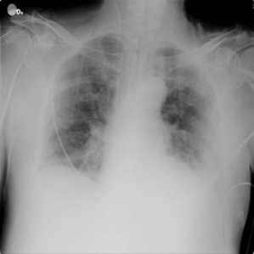
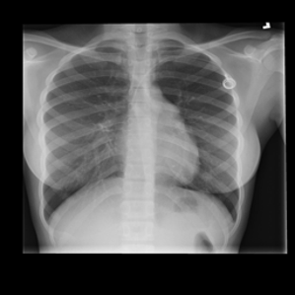
Example images from each class are shown in Fig. 1.

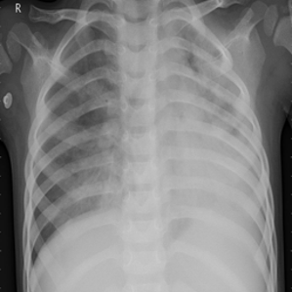
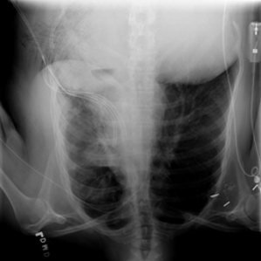
(a) Normal (b) COVID-19
(c) Lung Opacity (d) Viral Pneumonia

TABLE II: Dataset Split Distribution

Class | Train | Validation | Test
COVID-19 | 2893 | 181 | 542
Viral Pneumonia | 1076 | 67 | 202
Lung Opacity | 4809 | 301 | 902
Normal | 8153 | 510 | 1529

- Models
  - ResNet-50: ResNet-50 is beings used to differentiate features from normal to abnormal. It can extract features from images and is therefore used widely in the classification of diseases. It has 50 layers and is widely used for image classification, object classification, medical image analysis and feature extraction in deep learning pipelines.
ResNet-50 is being used at the first layer of classification to differentiate between normal and abnormal images. As neural networks get deeper training becomes harder to extract more features. ResNet-50 solves this with the use of residual learning.
  - ResNet-101: ResNet-101 is a same as the previous model. It is an extension of ResNet-50 with 101 layers. It is designed to improve feature learning in very deep networks.
ResNet-101 is used when images those are classified as abnormal. It differentiates between whether the images belong to COVID-19 class or not. It has more layers which allows capture of more intricate patterns. This increased depth pro-vides a higher capacity to learn more discriminative and subtle features.

  - DenseNet121: It is an efficient convolutional neural network architecture designed for image classification. It belongs to the base model in DenseNet family and thus offering high accuracy with significantly less parameters and much faster inference than traditional CNNs.
It is used at the last layers to differentiate between Lung Opacity and Viral Pneumonia. Its efficiency makes it well suited for complex, detailed diagnostic tasks where subtle differences are key.

PIPELINE

The project involves the development of a chest X-ray decision support pipeline which integrates three components: image classification and retrieval-augmented generation and local LLM-based reporting systems. The COVID-19 Radiography Dataset gets loaded into Google Colab by me who proceeds to preprocess the images through resizing and normalization before creating three separate data sets for training and validation and testing purposes.
I fine-tune pretrained CNN architectures which include ResNet and DenseNet on four clinically relevant classes that include Normal and COVID and Lung Opacity and Viral Pneumonia according to this dataset. The individual model predictions get combined into a weighted ensemble which I test on the held-out test set to find the optimal weights which create a reliable classifier for all four classes. I build a radiology knowledge base by processing a reference textbook PDF which I convert into smaller text segments that contain page-level metadata which I then index through dense embeddings and BM25 to enable hybrid retrieval from the entire corpus. I create a focused query for each predicted diagnosis that contains the search term "COVID chest X-ray radiological findings and differential diagnosis" while I conduct hybrid RAG to obtain the most pertinent passages and then I combine semantic and BM25 scores into a normalized format which enables me to select the top-k chunks to support the upcoming report. I create a structured prompt which contains the ensemble diagnosis and confidence level and complete class probability distribution and textbook context to request an LLM to produce a five-section clinical radiology report which includes clinical impression and radiological findings and differential diagnosis and clinical correlation/next steps and AI confidence assessment. The system requires users to install the software package through the Python package index however it prevents installation through the Python package index.

Model | Total parameters | Trainable parameters | Frozen (%)
ResNet50 | 24,033,604 | 525,572 | 97.8
ResNet101 | 43,025,732 | 525,572 | 98.8
DenseNet121 | 7,217,284 | 263,428 | 96.4

Rank | Model | Validation accuracy | Test accuracy | Test loss
1 | ResNet101 | 95.13% | 95.71% | 0.1306
2 | ResNet50 | 94.80% | 94.62% | 0.1517
3 | DenseNet121 | 94.28% | 93.06% | 0.1787

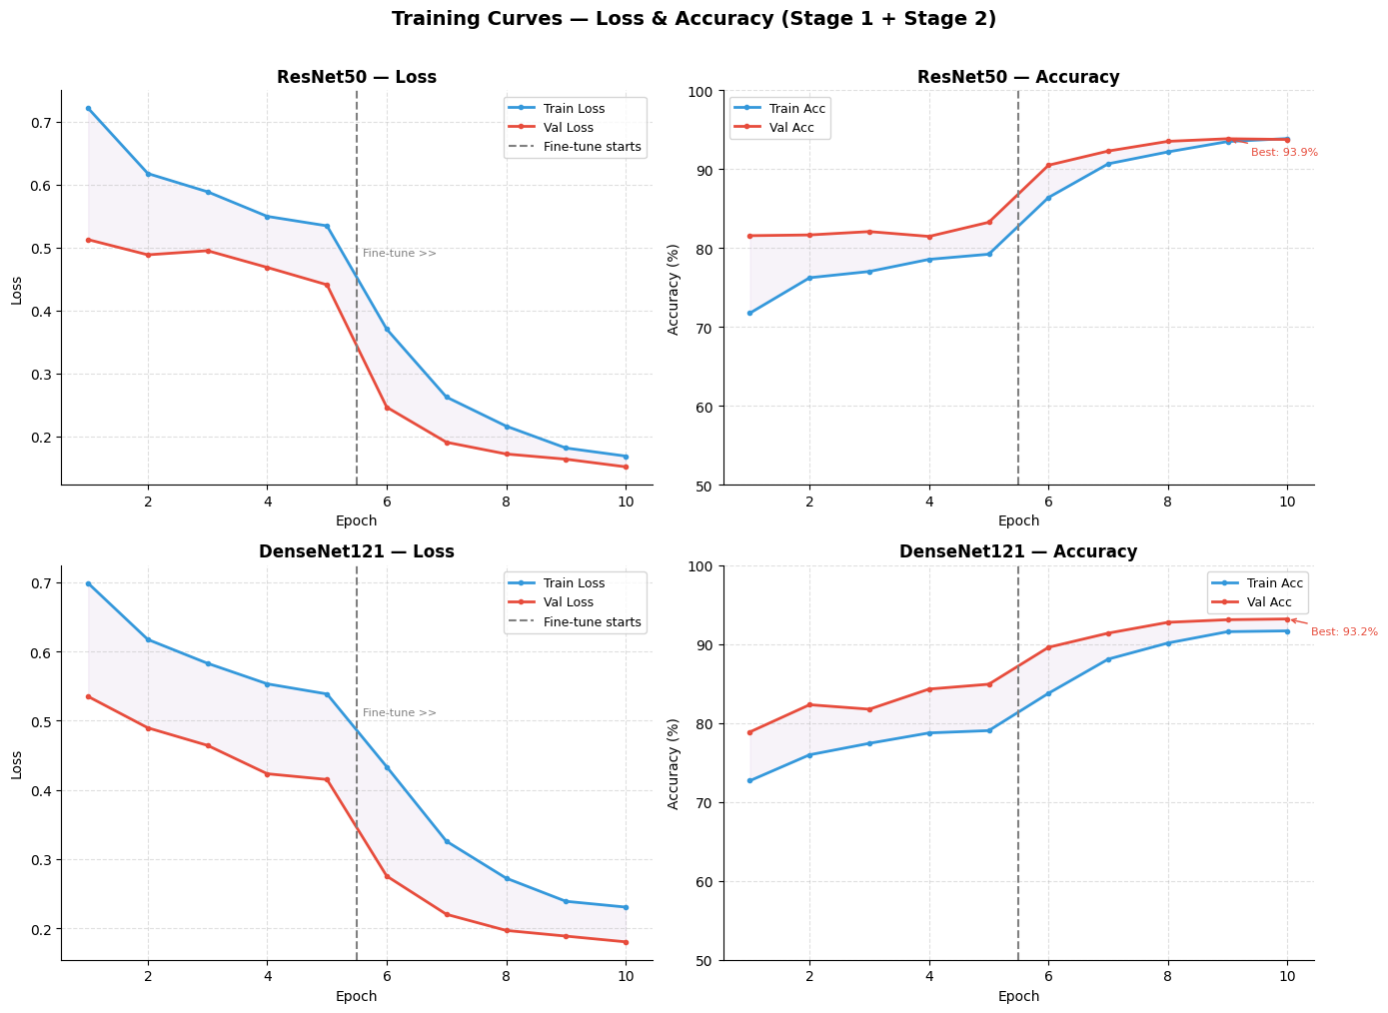

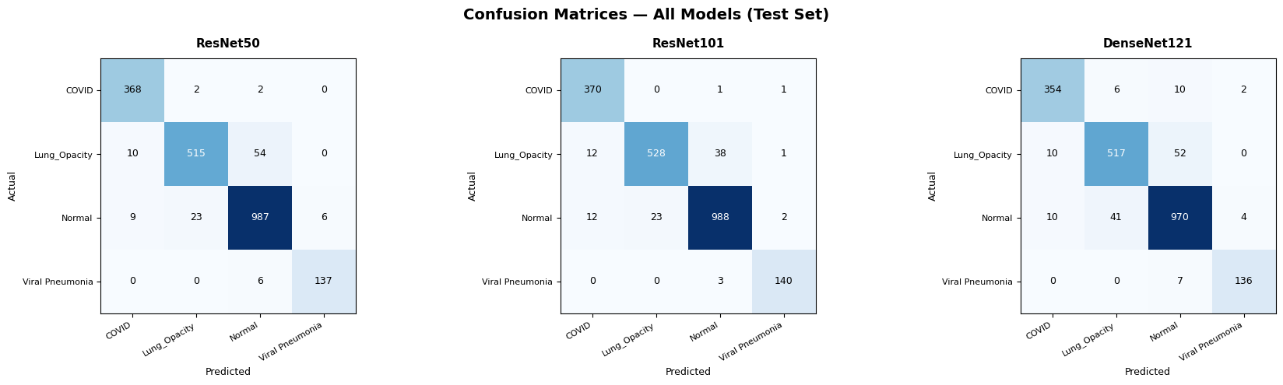

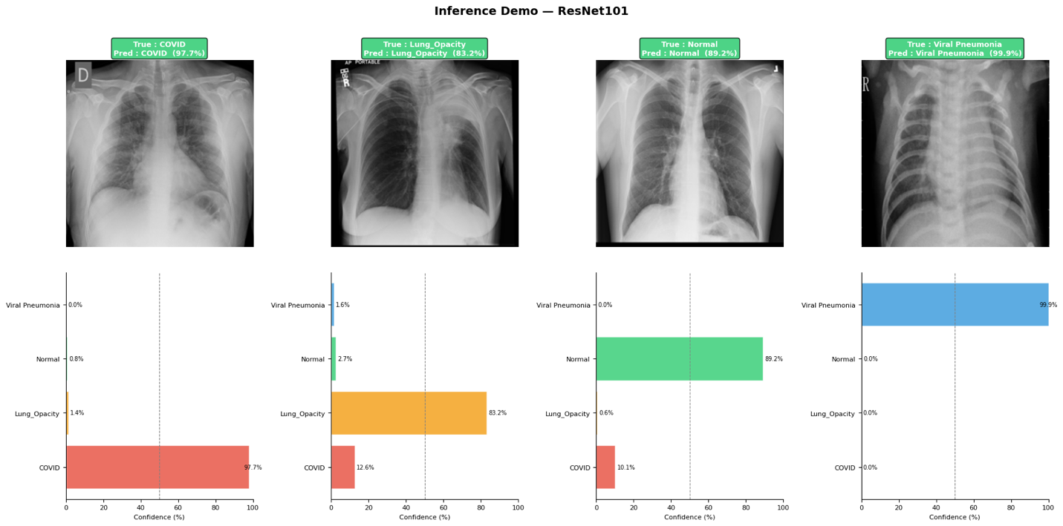

Model | Validation accuracy | Test accuracy | Macro F1
🥇 ResNet101 | 95.13% | 95.71% | 95.94%
🥈 🤝 Ensemble | 96.08% | 95.56% | 95.83%
🥉 ResNet50 | 94.80% | 94.62% | 95.00%
4️⃣ DenseNet121 | 94.28% | 93.06% | 93.70%

Metric | Value
Raw pages | 156
Total chunks | 350
Chunk size | 800 characters
Overlap | 80 characters
Chunks per book | medical_book.pdf → 350 chunks
Average chunk length | 615 characters
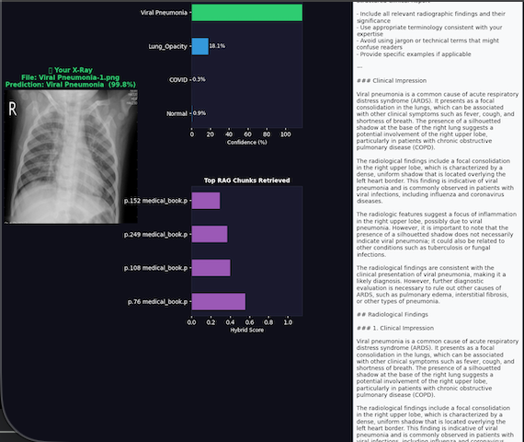

RELATED WORK

The use of computer vision and deep learning for diagnostics in medicine has grown exponentially, especially in interpreting chest x-ray images. The recent literature can be classified into the following categories: standard convolutional architectures, hybrid models, and transformer models, and methods that focus on clinical interpretability.

- CNN-Based Classification and Feature Extraction
The CNN model represents the basic structure that is used to implement almost all CXR analysis models. To solve the problem of recognizing infections in low-contrast areas of the lungs, scientists managed to develop efficient ResNet models that can reduce the effect of vanishing gradients and increase overall recognition accuracy. [1]. There has been much use of transfer learning due to the small size of the medical dataset used for research. Models based on MobileNetV3Large, ResNet-50, and EfficientNetB7 have been analysed; research has shown that light neural networks, such as MobileNetV3Large, can distinguish between very similar but dangerous thoracic pathologies in real time. [2]. In addition, multi-label algorithms using DenseNet121 are designed to recognize up to 14 chest pathologies simultaneously while utilizing patient data, such as age and gender, to assist in diagnosis. [3]. Proper image preprocessing and data augmentation plays an important role in balancing medical datasets and avoiding overfitting issues. [4].

- Advanced Architectures: Ensembles, Hybrids, and Trans formers
Recent research has tried to use ensemble and hybrid methodologies for enhancing performance beyond the single model performance. A new two-step ensemble of deep convolutional neural networks (DCNN) has shown excellent performance in classifying X-ray images into normal, lung disease, and heart disease categories before making a specific diagnosis. [5]. For more subtle diagnostic challenges, such as differentiating COVID-19 from regular viral pneumonia, hybrid methods that use CNNs to extract features and Long Short-Term Memory (LSTM) networks to classify sequences have proven highly effective. [6]. There has been a recent shift in thinking toward Vision Transformers (ViT). Comparative analyses demonstrate the superiority of ViTs, particularly when integrated with knowledge distillation, in the detection of significant respiratory conditions such as Tuberculosis and Pneumonia from CXRs, outperforming traditional CNN baselines. [7].

- Explainable AI (XAI) in Medical Imaging
Deep learning models are often ”black boxes,” which makes them hard to use in clinical settings where trust is very important, even though they are very accurate. For filling this gap, modern research focuses more on Explainable AI (XAI). Adding techniques like Gradient-weighted Class Activation Mapping (Grad-CAM) to transfer learning pipelines has be come a big trend. These techniques show how the deep network decisions are made visually. [8]. Recent diagnostic systems have looked into different CAM algorithms to come up with a plan for tools that not only sort diseases but also make it clear which areas of interest are driving the prediction. [9]. When models like Xception are paired with robustXAI methodologies they achieve accuracies exceeding 96% while still maintaining clinical transparency.

Citation (Year) | Objective | Dataset | Parameters | Result | Limitation / Re-mark | Architecture / Model
[1] (2022) | Optimum classification of thoracic diseases in low-contrast areas. | NIH ChestX-ray14 | 23.5M (ResNet-50 baseline) | Improved detection in difficult tissue spots. | May struggle with vanishing gradients in deeper layers. | ResNet CNN
[2] (2025) | Real-time detection of life-threatening anomalies. | Standard CXR | 5.4M  (MobileNet) /  23.5M (ResNet) | MobileNet proved most efficient for real-time use. | High visual similar-ity between diseases remains a challenge. | MobileNetV3Large, ResNet-50
[3] (2022) | Simultaneous detection of 14 chest conditions. | CXR + Meta-data | 8M (DenseNet) / 24M (Inception) | High accuracy multi-label classification. | Reliance on patient metadata limits use on raw images. | DenseNet121, In-ception V3
[4] (2024) | Balance medical datasets to prevent model overfitting. | CheXpert | Custom CNN (varies) | Highly robust against imbalanced classes. | Preprocessing over-head increases com-putational time. | DenseNet-inspired CNN
[5] (2022) | Classify diseases by first sorting infected organs. | Mixed CXR | Multiple CNNs (High parameter count) | Excellent multi-class sorting and accuracy. | Two-step pipeline increases inference latency. | Deep Ensemble (DCNN)
[6] (2022) | Differentiate COVID-19 from standard viral pneumonia. | COVID-19 DB | CNN backbone + LSTM layers | High precision in sep-arating subtle visual features. | Complex architecture; harder to train from scratch. | Hybrid CNN + LSTM
[7] (2025) | Detect major respira-tory conditions using attention. | Mixed CXR | 86M (ViT-Base baseline) | Outperformed traditional CNN baselines. | Transformers require massive  datasets and compute. | Vision Transformer (ViT)
COV-SNET  Paper (2021) | Isolate COVID-19 from overlapping pulmonary diseases. | 100,000+ CXRs | Custom Architecture | High specificity for COVID-19 classifica-tion. | Highly specialized; may not generalize well. | Pretrained COV-SNET
[8] (2024) | Predict lung disease and provide visual in-terpretation. | Standard CXR | 138M (VGG16  baseline) | High accuracy with visual bounding boxes. | Grad-CAM can highlight irrelevant background artifacts. | Transfer Learning (VGG16)
[9] (2024) | Tackle the AI ”black box” problem in med-ical imaging. | Clinical CXR | Varies by back-bone model | Provided blueprint for clinical diagnostic tools. | Focuses more on explainability than raw SOTA accuracy. | Deep Learning + CAM
[10] (2024) | 5-class lung disease classification with transparency. | Mixed COVID DB | 22.8M (Xception baseline) | Achieved 96.21% accuracy with visual reasoning. | Requires fine-tuning; heavy for mobile deployment. | Fine-tuned Xcep-tion

CONCLUSION

The Proposed hierarchical lung disease classification demonstrates the effectiveness of deep learning techniques in predicting the disease by looking at the chest X-ray images. Our system effectively distinguishes between Normal and abnormal cases, further identifies COVID-19 cases, and finally classifies non-COVID abnormalities into Lung Opacity and Viral Pneumonia. Our multistage system not only reduces complexity but also improves accuracy by narrowing down decision making at each level.
We have combined pre-trained models such as ResNet-50, ResNet-101, and DenseNet121 and further we have combined it with data augmentation which enables the system to achieve high performance with the dataset we have. The use of Grad-CAM visualization improves model interpretation of images by highlighting the parts of X-ray which further enhances the trust in our model and also increases the trust in diagnosis.
Among all the important features we have also used Retrieval-Augmented Generation (RAG) based reporting system. It helps to bridge the gap between the diagnosis of our model and clinical usability by giving accurate medical reports. This makes our model not only diagnosis tool but also a decision-making system for healthcare professionals.
Overall, we have tried to provide a framework that gives highly scalable and efficient solution for diagnosis of lung based disease. It has the potential to give accurate results Fastly and at the same time it reduces human errors and improves patient outcomes. In future this work can be further enhanced by adding additional disease classes, using more diverse datasets and optimizing the system for real-time deployment in clinical environments.

REFERENCES
[1] Author Name(s), “Analysis and Optimum Classification of Thoracic Diseases in Chest X-Rays Using CNN,” IEEE Xplore, 2022.
[2] Author Name(s), “Development of Classification Model for Thoracic Diseases with Chest X-ray Images Using Deep Convolutional Neural Network,” ResearchGate, 2025.
[3] Author Name(s), “Multi-Label Chest X-Ray Classification via Deep Learning,” ResearchGate, 2022.
[4] Author Name(s), “Classification of Chest X-Ray Diseases Through Image Processing and Analysis Techniques,” ResearchGate, 2024.
[5] Author Name(s), “Chest Diseases Classification Using CXR and Deep Ensemble Learning,” Semantic Scholar, 2022.
[6] Author Name(s), “Classification of Chest X-ray Images Using a Hybrid Deep Learning Method,” ResearchGate, 2022.
[7] Author Name(s), “Identification of Lung Disease via X-Ray Images Using Knowledge Distillation and Vision Transformer,” IEEE Xplore, 2025.
[8] Author Name(s), “Chest X-rays Analysis for Lung Disease Prediction and Interpretation Using Transfer Learning,” IEEE Xplore, 2024.
[9] Author Name(s), “Explainable Deep Learning Diagnostic System for Prediction of Lung Disease from Medical Images,” PubMed, 2024.
[10] Author Name(s), “Explainable Lung Disease Classification from Chest X-Ray Images Utilizing Deep Learning and XAI,” ResearchGate, 2024.
[11] E. Khalili, D. Sanchez-Morillo, B. Priego-Torres, and A. León-Jiménez, “Localization and Classification of Abnormalities on Chest X-ray Images Using a Mamba-X Model,” Expert Systems with Applications, vol. 284, p. 127929, 2025.
[12] B. S. (Author unclear), S. E. Yuksel, and B. (Author unclear), “Automated Classification of Chest X-rays: A Deep Learning Approach with Attention Mechanisms,” BMC Medical Imaging, vol. 25, no. 1, p. 71, Mar. 2025.
[13] G. D. Deepak and S. K. Bhat, “A Multi-Stage Deep Learning Approach for Comprehensive Lung Disease Classification from X-ray Images,” Results in Engineering, 2025.

